Lesson 2: Describing the Center of a Distribution
In previous work with data distributions, you learned how to derive the mean and the median of a data distribution. This lesson builds on your previous work with a center.
Classwork
Measures of Central Tendencies are numbers that describe an entire set of data.
They represent a centralized or middle value.

Three most commonly used are:

Mean | The sum of the numbers divided by the number of numbers in the set.
Median | The middle number when the numbers in the set are arranged in numerical order.  If there are two middle numbers find the mean of the two numbers.
Mode | The number that occurs most often in the set.  Could be no mode or more than one

A teacher marked a set of 32 test papers. The grades earned by the students were as follows:

90, 85, 74, 86, 65, 62, 100, 95, 77, 82, 50, 83, 77, 93, 73, 72,
98, 66, 45, 100, 50, 89, 78, 70, 75, 95, 80, 78, 83, 81, 72, 75

Find the mean, median, and mode

Make a dot plot of the scores above.
A dot plot provides a graphical representation of data distributions, helping us visualize the distribution.

________________________________________________________________________

Exercises
Consider the following three sets of data.
Data Set 1: Pet owners
30 Students from River City High School were randomly selected and asked, “How many pets do you currently own?” The results are recorded below:

0 | 0 | 0 | 0 | 1 | 1 | 1 | 1 | 1 | 1 | 1 | 1 | 1 | 1 | 2
2 | 2 | 2 | 3 | 3 | 4 | 5 | 5 | 6 | 6 | 7 | 8 | 9 | 10 | 12

- Make dot plot of the data. Use the following scales:

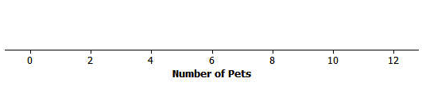

- Calculate the mean number of pets owned by the 30 students from River City High School.

- Calculate the median number of pets owned by the thirty students.

- What do you think is a typical number of pets for students from River City High School? Explain how you made your estimate.

Data Set 2: Length of the east hallway at River City High School
Twenty students were selected to measure the length of the east hallway. Two marks were made on the hallway’s floor, one at the front of the hallway and one at the end of the hallway. Each student was given a meter stick. Students were asked to use their meter sticks to determine the length between the marks to the nearest tenth of a meter. The results are recorded below:
8.2 | 8.3 | 8.3 | 8.4 | 8.4 | 8.5 | 8.5 | 8.5 | 8.5 | 8.5
8.6 | 8.6 | 8.6 | 8.6 | 8.7 | 8.7 | 8.8 | 8.8 | 8.9 | 8.9

1. Make dot plot of the data. Use the following scales:

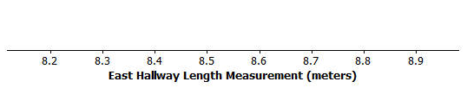

2. Why do you think that different students got different results when they measured the same distance of the east hallway?

3. What is the mean length of the east hallway data set? What is the median length?

- A construction company will be installing a handrail along a wall from the beginning point to the ending point of the east hallway. The company asks you how long the handrail should be. What would you tell the company? Explain your answer.

Data Set 3: Age of cars
Twenty-five car owners were asked the age of their cars in years. The results are recorded below:
0 | 1 | 2 | 2 | 3 | 4 | 5 | 5 | 6 | 6 | 6 | 7 | 7
7 | 7 | 7 | 7 | 8 | 8 | 8 | 8 | 8 | 8 | 8 | 8

1. Make dot plot of the data. Use the following scales:

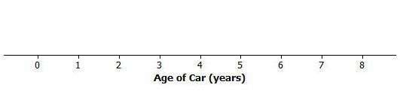
2. Describe the distribution of the age of cars.

3. What is the mean age of the twenty-five cars? What is the median age?
Why are the mean and the median different?

4. What number would you use as an estimate of the typical age of a car for the twenty-five car owners?
Explain your answer.

Note:
- The mean and the median of the distribution are numerical summaries of the center of a data distribution.
- When the distribution is nearly symmetrical, the mean and the median of the distribution are approximately equal.
- When the distribution is not symmetrical (often described as skewed), the mean and the median are not the same.
- For symmetrical distributions, the mean is an appropriate choice for describing a typical value for the distribution.
- For skewed data distributions, the median is a better description of a typical value.

Lesson Summary:
- A dot plot provides a graphical representation of data distributions, helping us visualize the distribution.
- The mean and the median of the distribution are numerical summaries of the center of a data distribution.
- When the distribution is nearly symmetrical, the mean and the median of the distribution are approximately equal. When the distribution is not symmetrical (often described as skewed), the mean and the median are not the same.
- For symmetrical distributions, the mean is an appropriate choice for describing a typical value for the distribution. For skewed data distributions, the median is a better description of a typical value.

Problem Set
Consider the following scenario. The company that created a popular video game, “Leaders,” plans to release a significant upgrade of the game. Users earn or lose points for making decisions as the leader of an imaginary country. In most cases, repeated playing of the game improves a user’s ability to make decisions. The company will launch an online advertising campaign, but at the moment, they are not sure how to focus the advertising. Your goal is to help the company decide how the advertising campaign should be focused. Five videos have been proposed for the following target audiences:
Video 1: Target females with beginning level scores.
Video 2: Target males with advance level scores.
Video 3: Target all users with middle range scores
Video 4: Target males with beginning level scores.
Video 5: Target females with advanced level scores.

- Why might the company be interested in the developing different videos based on user score?

- Thirty female users and twenty-five male users were selected at random from a database of people who play the game regularly. Each of them agreed to be part of a research study and report their scores. A leadership score is based on a player’s answers to leadership questions. A score of 1 to 40 is considered a beginning level leadership score, a score of 41 to 60 is considered a middle level leadership score, and a score of greater than 60 is considered an advanced level leadership score.
Use the following data to make a dot plot of the female scores, a dot plot of the male scores, and a dot plot of the scores for the combined group of males and females.

Female scores:
10 | 20 | 20 | 20 | 30 | 30 | 30 | 40 | 40 | 40
50 | 50 | 55 | 65 | 65 | 65 | 65 | 65 | 70 | 70
70 | 70 | 76 | 76 | 76 | 76 | 76 | 76 | 76 | 76

Male scores:
15 | 20 | 20 | 25 | 25 | 25 | 25 | 30 | 30 | 30
30 | 30 | 30 | 35 | 35 | 35 | 35 | 35 | 40 | 40
40 | 45 | 45 | 45 | 50

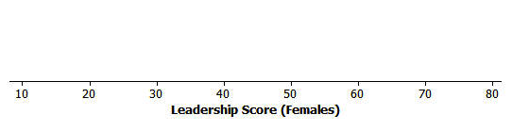
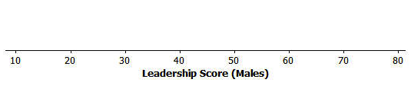

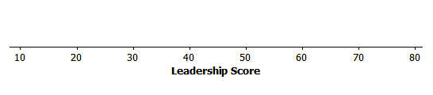

- What do you think is a typical score for a female user? What do you think is a typical score for a male user? Explain how you determined these typical scores.

- Why is it more difficult to report a typical score for the overall group that includes both the males and females?

- Production costs will only allow for two video advertisements to be developed. Which two videos would you recommend for development? Explain your recommendations.

- Find three consecutive integers algebraically, whose sum is 639. The pattern below generates consecutive integers.
1st 2nd 3rd
x x + 1 x + 2

- Find the product (x + 4)(x² –3x – 6)

